EXP 9:

GIT/GITHUB:

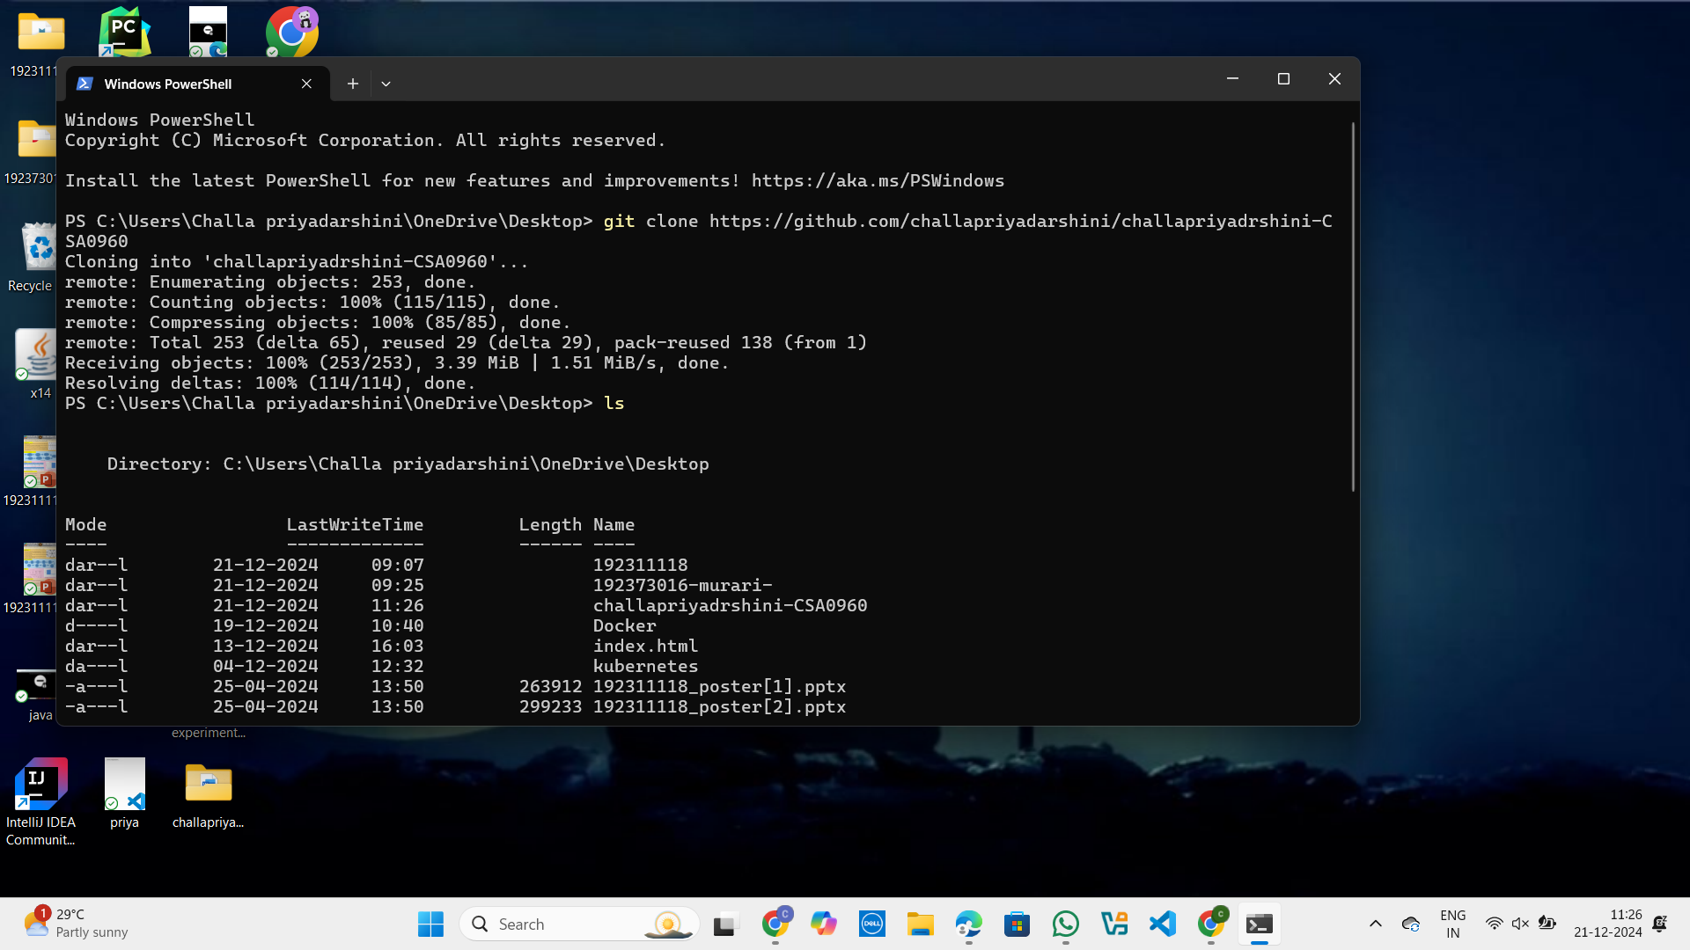

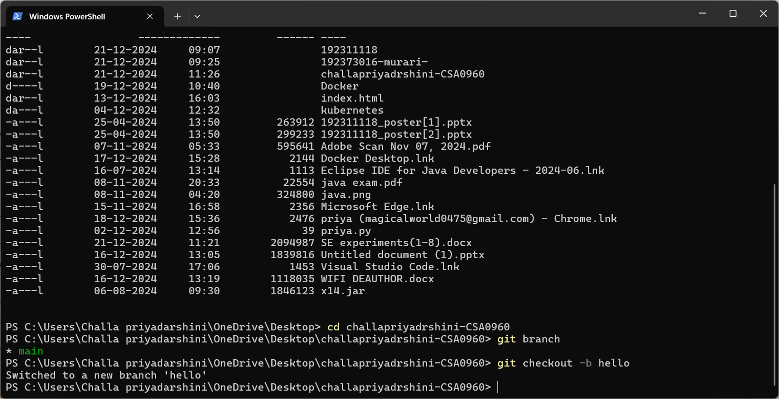

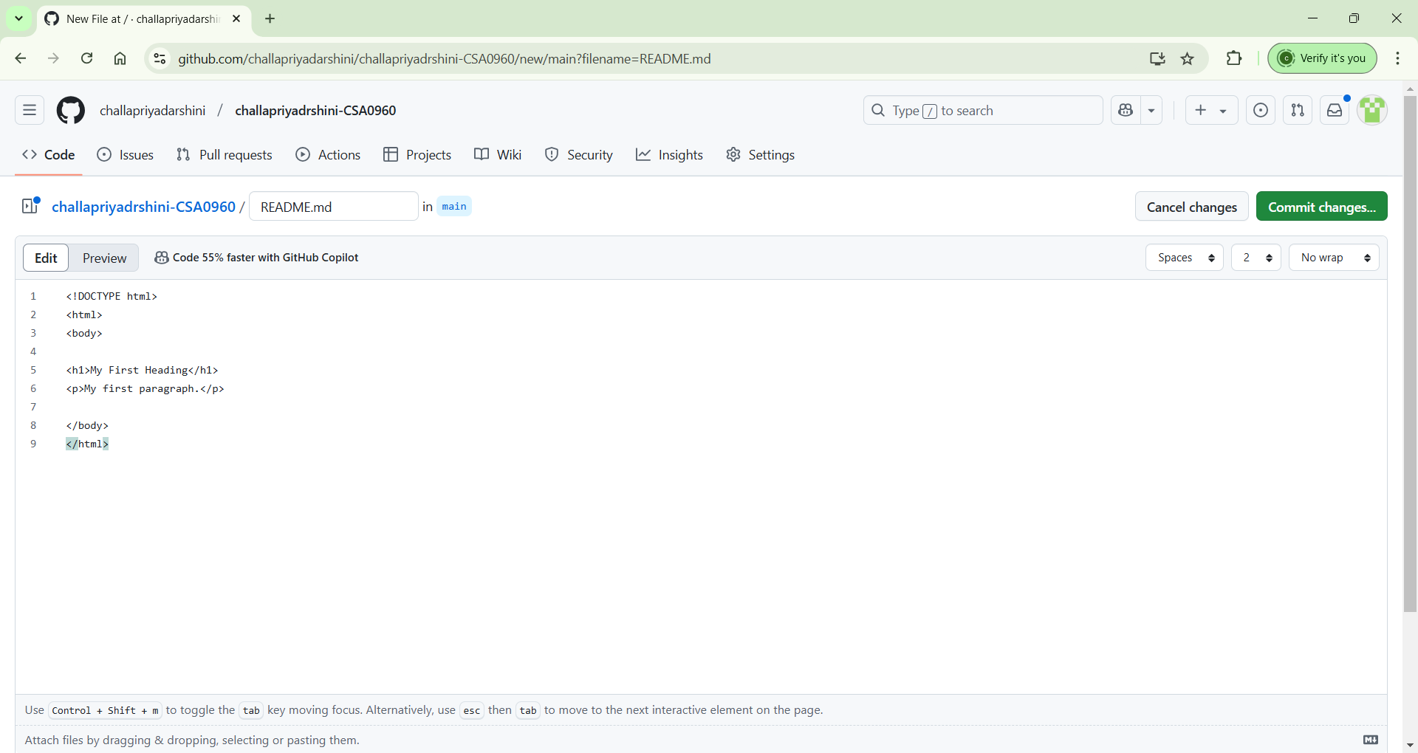

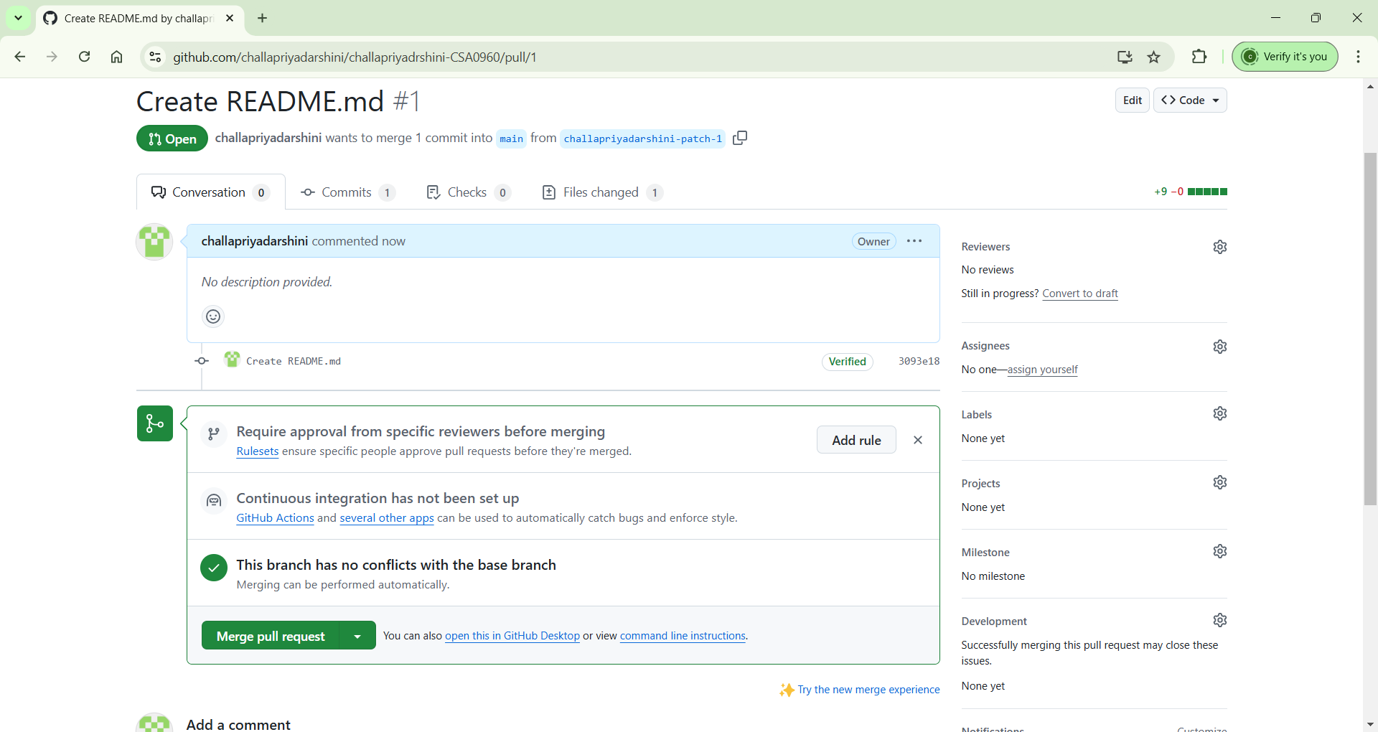

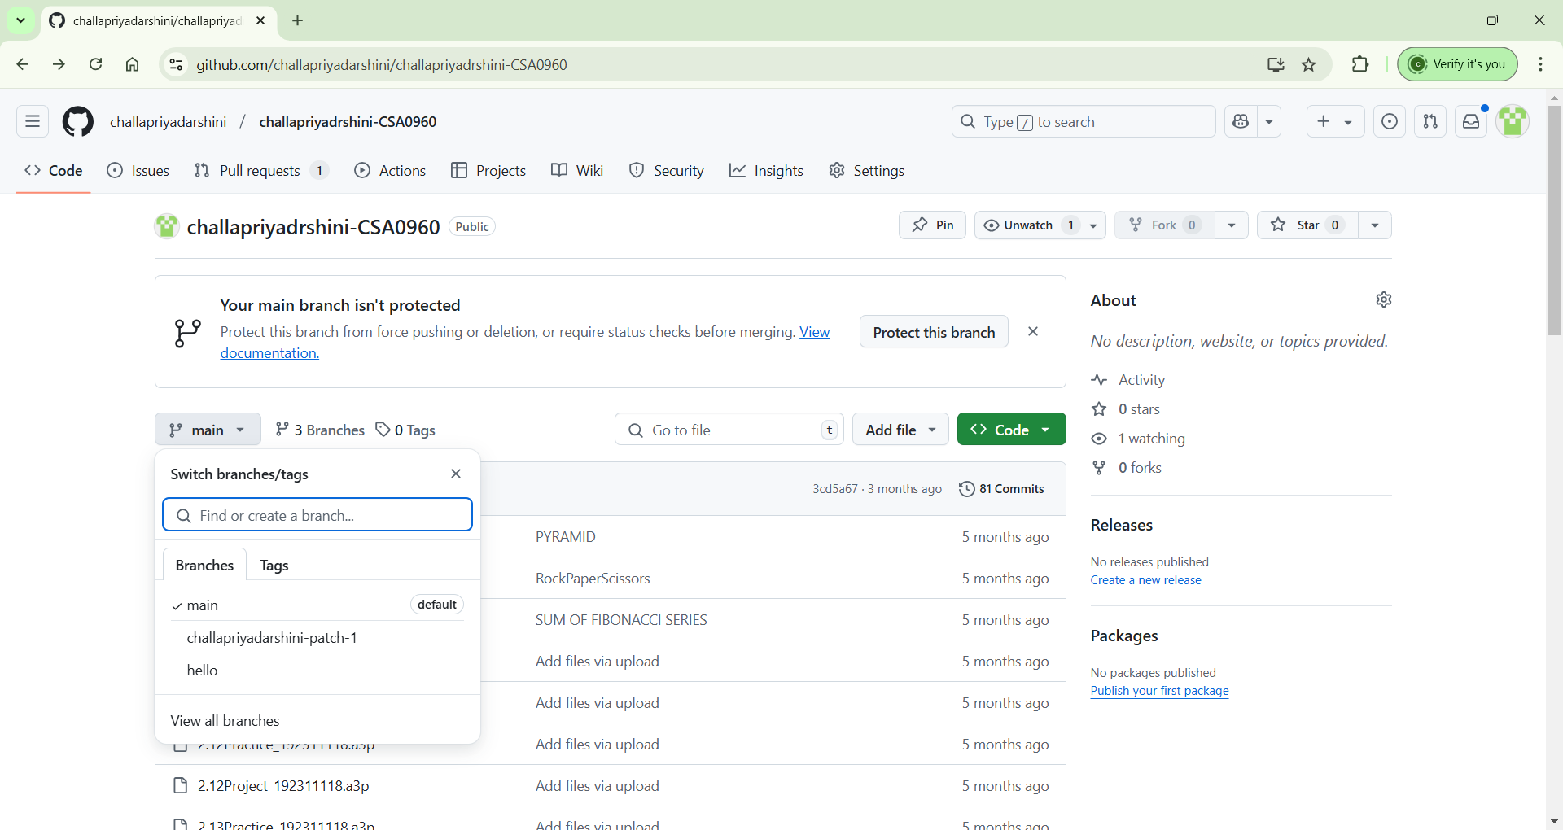

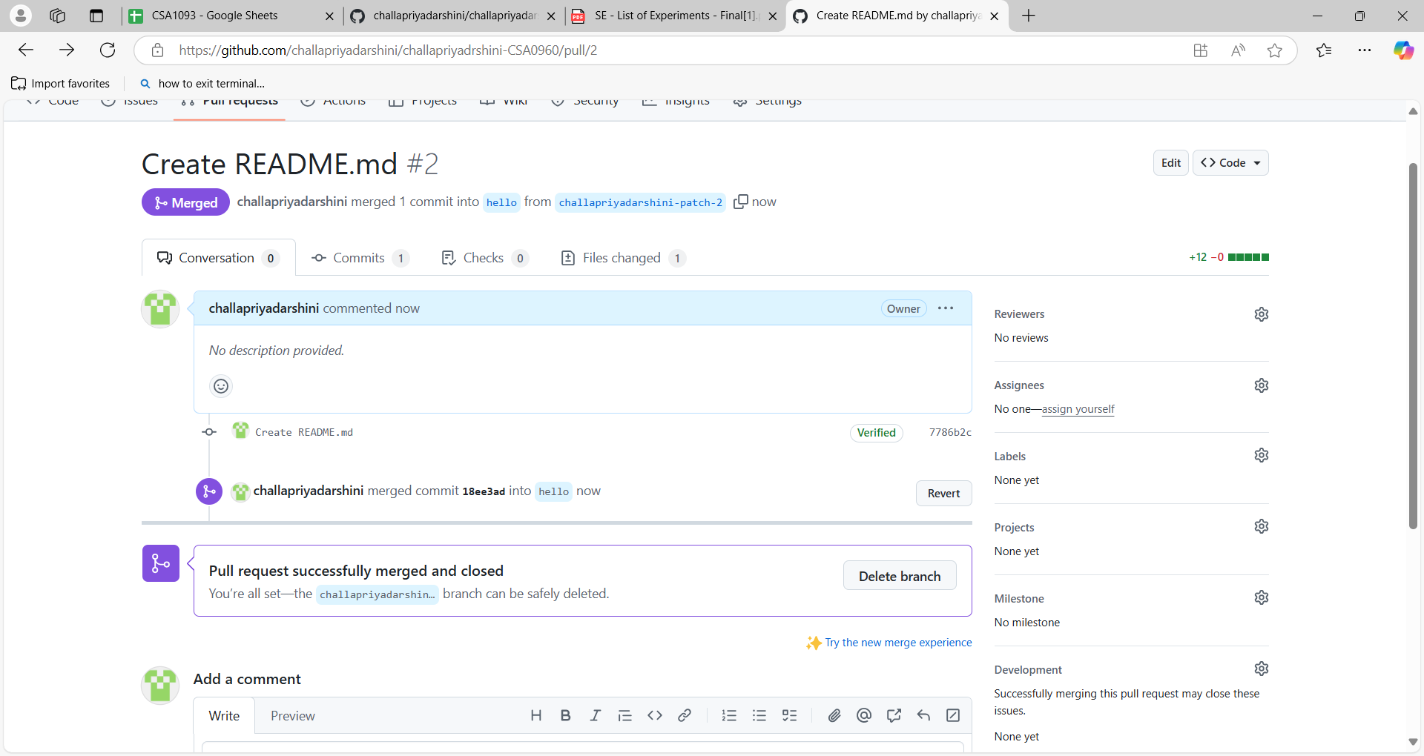

Pull request: [Create README.md by challapriyadarshini · Pull Request #2 · challapriyadarshini/challapriyadrshini-CSA0960](https://github.com/challapriyadarshini/challapriyadrshini-CSA0960/pull/2)

EXP 10:

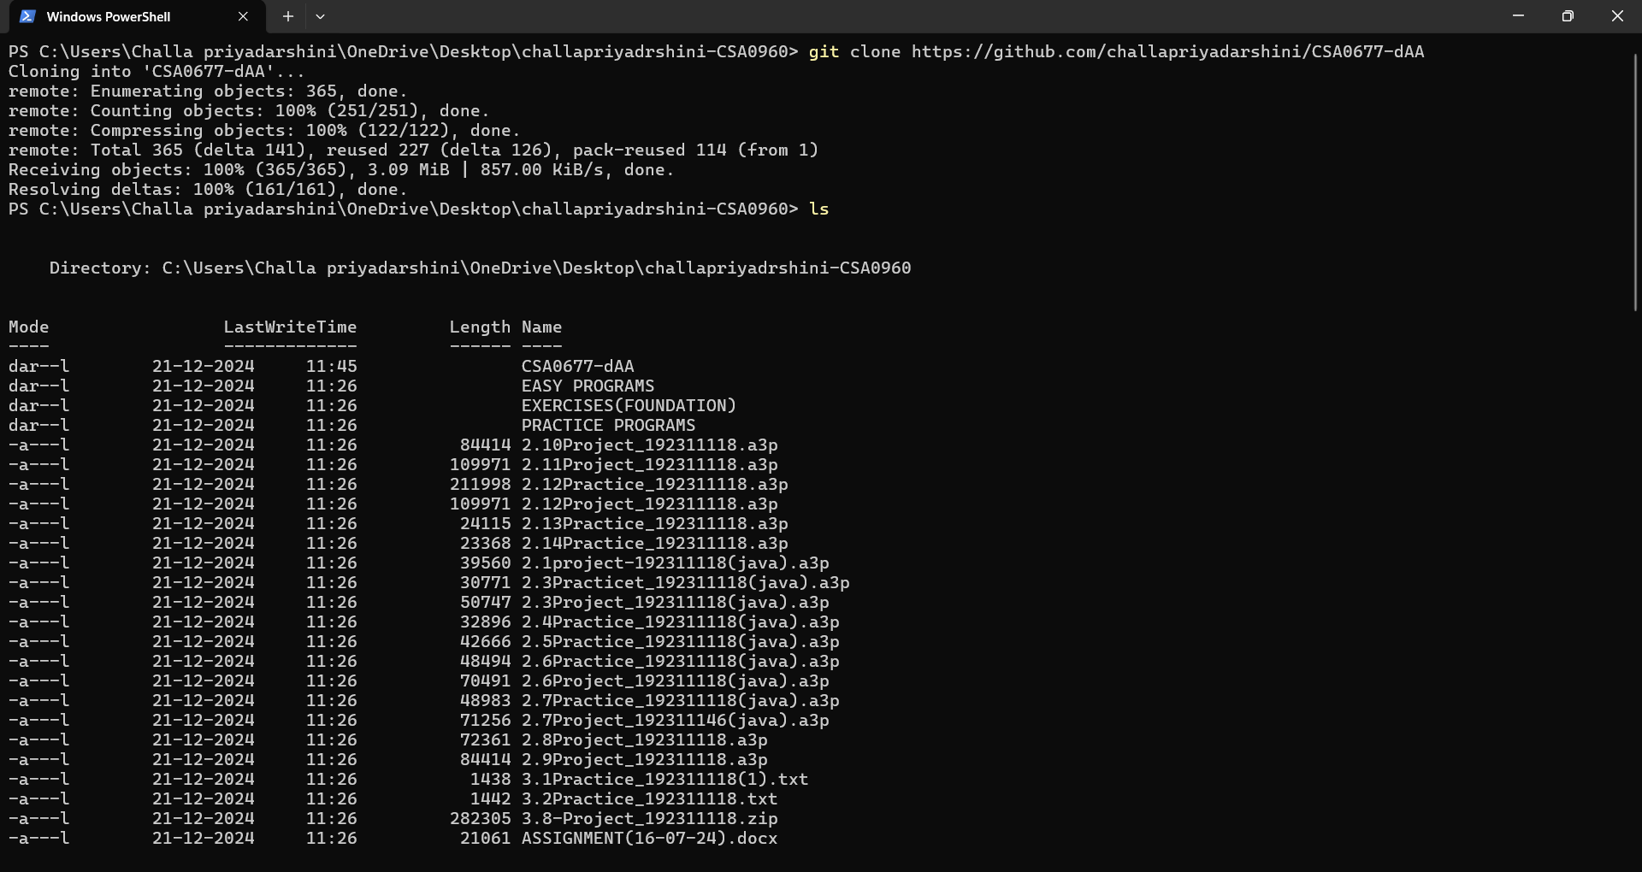

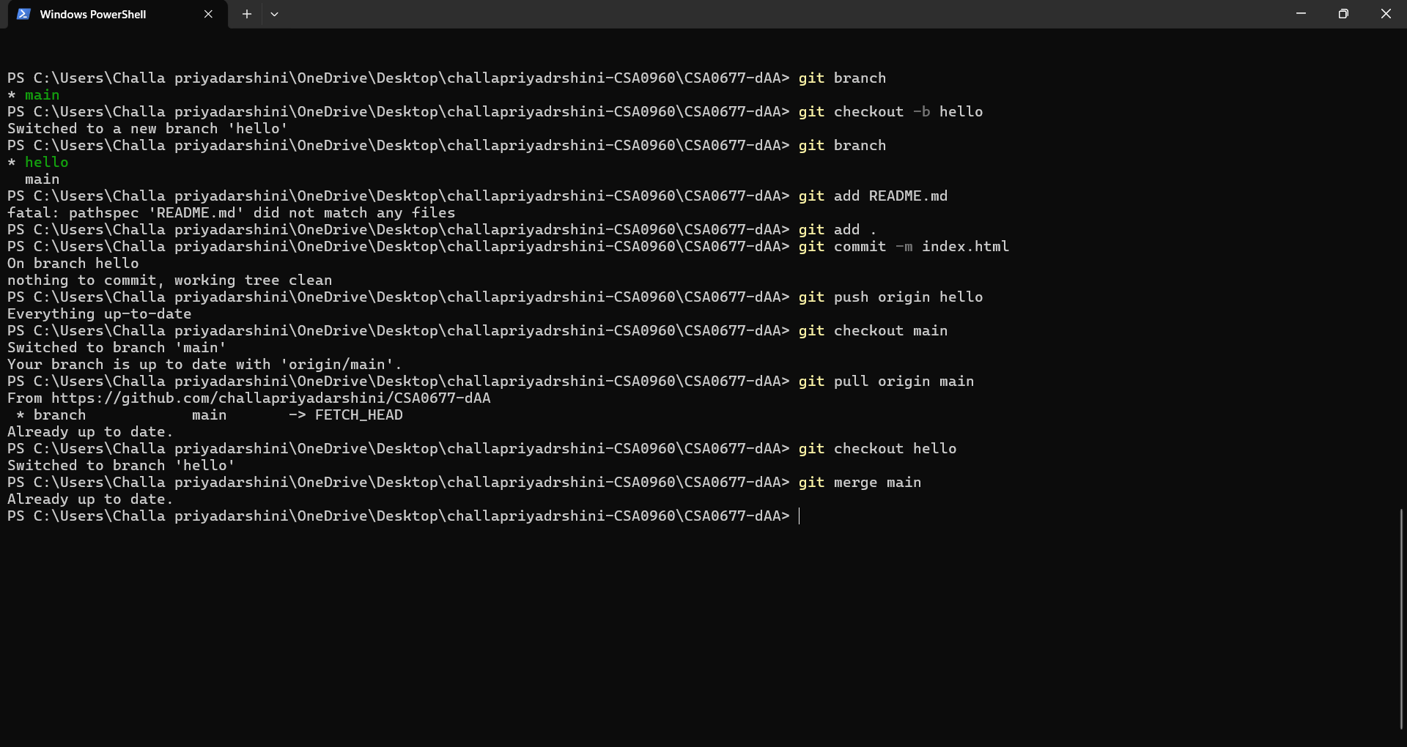

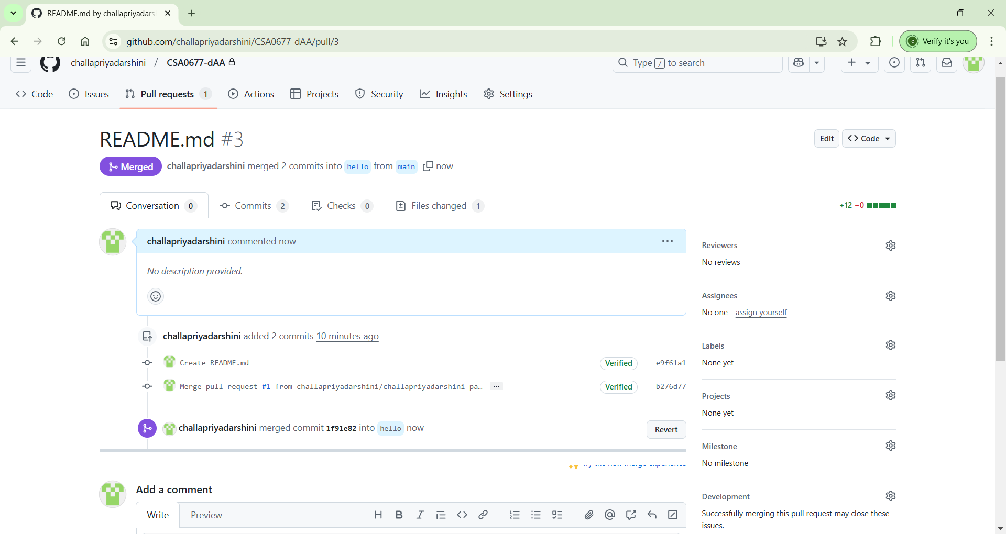

Pull Request Link: [https://github.com/challapriyadarshini/CSA0677/pull3](https://github.com/challapriyadarshini/CSA0677/pull389)